The Chicago Bears, Blackhawks, Bulls, Cubs, and White Sox are more than just sports teams. With the large and devoted Chicago fan base, sports are more than just games; they’re a way of life. But many Chicagoans do not realize that there is another sports team playing for their great city, and it is right under their very noses.

This team has won two National Championships and holds their practices in the heart of Chicago April through August. The name of this outstanding team? The Rehabilitation Institute of Chicago Cubs Wheelchair Softball Team.

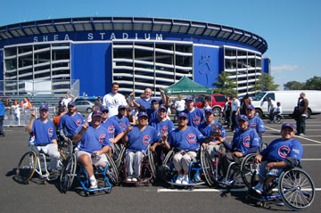
The RIC Cubs won the National Championship this past year in 2008 and had won previously in 2002. Wheelchair softball is kind of like regular softball , just with a few modified rules and dimensions of the playing field. A team is required to have ten players and is played on hard surface parking lots under the official rules of 16-inch slow pitch softball as approved by the Amateur Softball Association of America.

A few of the rules are that all participants must be in a manual wheelchair with foot platforms, all teams are required to have a quadriplegic on their team in active play, and the teams are balanced by using the following point system. A team cannot have greater than 22 points playing on the field at any time.
The RIC Cubs team in front of Shea Stadium after winning the 2008 NWCA 34th National Wheelchair Softball Tournament.

Classification | Definition | Number of points
Quadriplegic | person paralyzed at arms and legs | 1 point
Class I | those who have no functional use of their abdomen and no functional motor power below T7 (vertebrae near the middle of the spine) | 1 point
Class II | those who have no useful motor power below L2 (vertebrae near upper leg) | 2 points
Class III | all other physical disabilities related to lower paralysis at or below L3 (vertebrae near pelvis) | 3 points

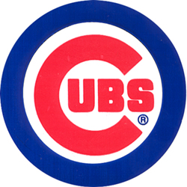
The National Wheelchair Softball Association was formed in 1976 and Chicago wasted no time getting in on the action. In 1980, the Chicago Pacemakers were born and any new team joining in the NWSA was most likely from Illinois. Illinois had the Chicago Pacemakers, University of Illinois, Champaign-Urbana, Urbana Black Knights, RIC Rollers, Chicago Sidewinders, Windy City Snakes, and the Chicago Bulls in their history.
The RIC Cubs logo.
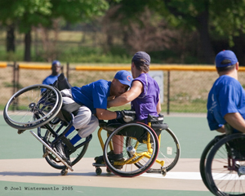
The birth of the RIC Chicago Cubs started when there was a sponsorship deal between the RIC Rollers and Cubs Care, a charity group of the Chicago Cubs organization. The RIC Cubs were also the first wheelchair softball program to be sponsored by a major league baseball team.

One of the most important things to happen to the RIC Cubs was the creation of their own Wheelchair Softball Field. After they won the National Championship in 2002, Cubs Care and many other donators made it possible for their field to be built. In the summer of 2003, the state’s first wheelchair softball field at McFetridge Sports Center/California Park was open to the public. California Park is a state-of-the-art facility built by the RIC Cubs, Cubs Care, The Baseball Tomorrow Fund and the Chicago Park District.
RIC Cubs player Jose Pena tagging out an opponent at 3rd base.

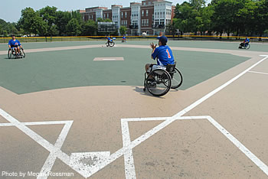
"The Chicago Cubs and Cubs Care are very proud to be involved in this unique facility," said John McDonough, Vice President, Marketing and Broadcasting, Chicago Cubs. "Participation in our wheelchair softball programs has increased greatly over the last nine years - and with it, the need for a place the athletes can call their own. We are thrilled to be part of this project."

As part of the opening celebration, the RIC Cubs received championship rings for winning both the 2002 National Wheelchair Softball Tournament and the 2002 Wheelchair World Series.
The RIC Cub’s Wheelchair Softball Field, build in 2003 at the McFetridge Sports Center/California Park.

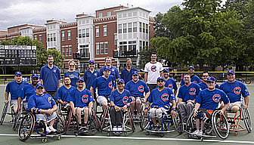
The team is led by Competitive Sports Specialist at RIC, Samuel Glomp. Team members of the 2008 RIC Chicago Cubs were Hector Bruno, Eddie Clafford, Dan Ferreira, Alex Grunstein, Wataru Horie, Jarvis Jackson, Curtis Lease, Dave Lewis, Sean Mizlo, Alex Parra, Jose Pena, Hector Perez, Jeremy Smith, Kurt Smith, Jackson Tracy, and Ki Yun.

The RIC Cubs are a National Wheelchair Softball Association sanctioned team who compete with fellow Chicago teams such as the Midwest Cicero Flyers Wheelchair Softball Team and the Vaughan Paralyzed Veterans of America White Sox. There are 15 NWSA sanctioned teams in the US and five international wheelchair softball teams.
The 2008 RIC Cubs at their home field.
For more information on the RIC Cubs, please go to the NWCS website at www.wheelchairsoftball.org. Share your support by watching some of the games and GO CUBS GO!
MEET THE TEAM:

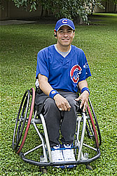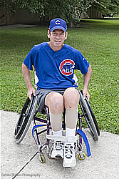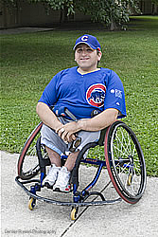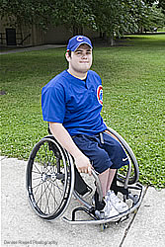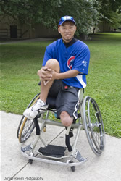
Hector Bruno Eddie Clafford Dan Ferreira Alex Grunstein Wataru Horie
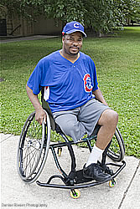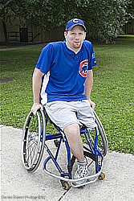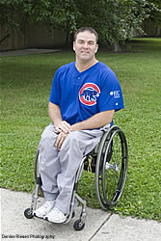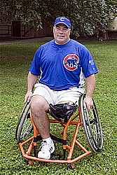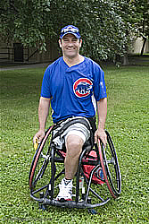
Jarvis Jackson Curtis Lease Dave Lewis Sean Mizlo Alex Parra
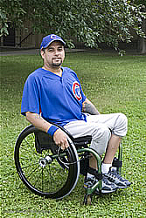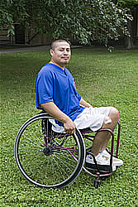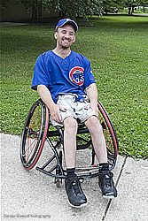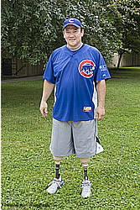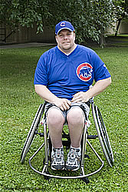
Jose Pena Hector Perez Jeremy Smith Kurt Smith Jackson Tracy

Action shots:
